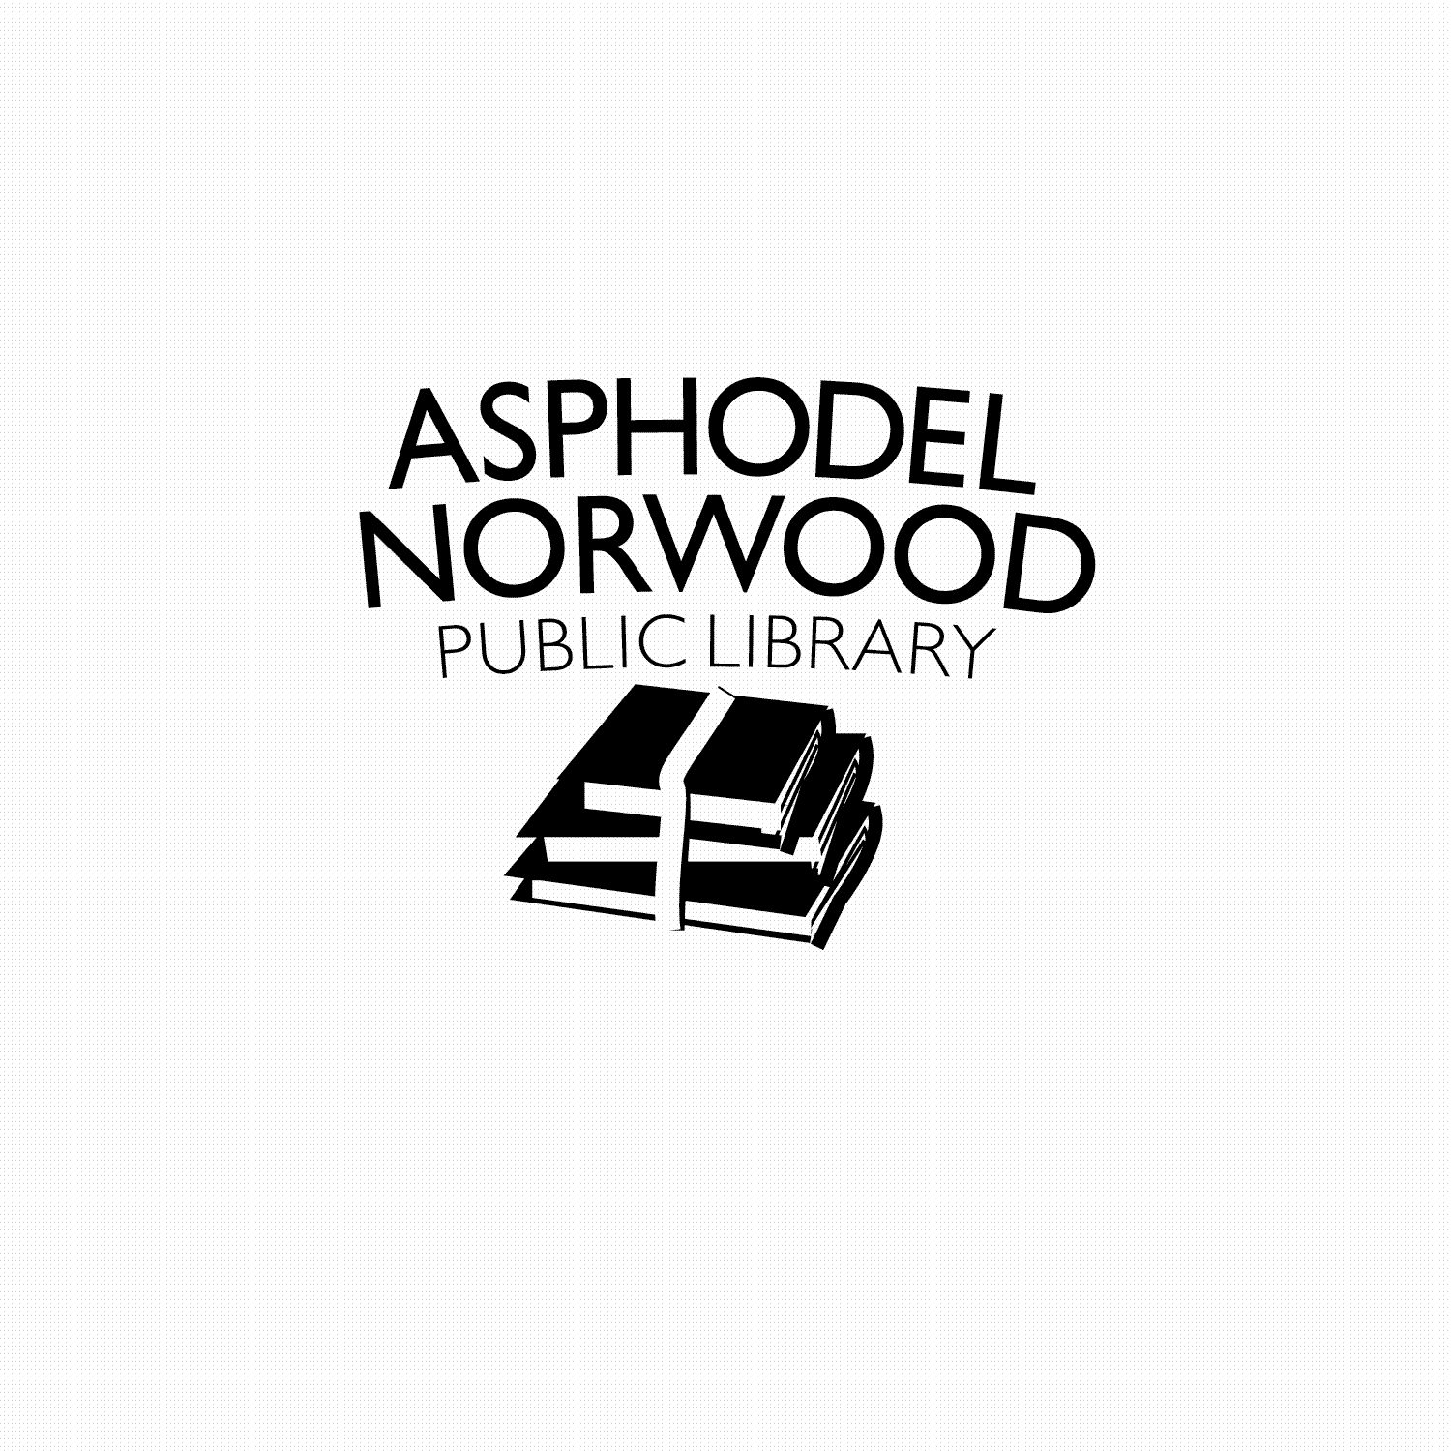
Home Delivery Service

The Asphodel-Norwood Public Library, in partnership with our local volunteers, offers a free Home Delivery Service to local residents who have barriers to physically accessing the library.

Getting started:
Complete the attached “ANPL Home Delivery Service Registration” form. Submit your form to your Activities Director or Support Services Staff who will ensure it makes its way to the library.
How it works:
Library staff will check out your books and bag them. A volunteer delivers the book bag right to your door and will pick up the bag of books from the previous delivery and return them to the library. The book bag swap happens every second Wednesday. It is helpful if you can please remember to hang your library book bag on your outside door knob with your books to be returned.
Responsibilities of participants:
The Asphodel-Norwood Public Library does not charge overdue fines for participants in the Delivery Service; however, we do expect to get items back (undamaged) in a timely manner.
If an item is damaged or lost, participants are liable for charges incurred to repair or replace the item. Borrowing privileges may be suspended until long-overdue items are returned or replacement costs for missing/damaged items are met.
How to reach the Library:
Feel free to correspond with us by dropping a letter in your book bag. We’ll do our best to make sure that the literature we send matches your interests and meets your needs.
If, at any time, you would like to speak directly with a Librarian, please contact Cheryl at 705-639-2228.
Thank you for your interest in our service and we look forward to working with you to meet your needs!
ANPL Home Delivery Registration Form

Date: _______________
Name: ________________________________________________________________________
Address: ______________________________________________________________________
Telephone: ____________________________________________________________________
Alternate Contact: ______________________________________________________________
Delivery Instructions: ____________________________________________________________
Format:
____ Large Print ____ Regular Print ____ Audio-book ____ CNIB audio discs

Subjects (check all that apply):
___ Mystery ___ Suspense ___ Romance ___ Western ___ Fantasy ___ Sci-Fi
___ Historical fiction ___ Christian fiction ___ Biography ___ History
___ Other (please specify):________________________________________________________

Number of items per delivery: ________
Favourites (any specific authors, titles, series, etc.): ___________________________________

Comments or other suggestions: __________________________________________________

Office Use Only:
Library Card Number: ___________________________________________________________

